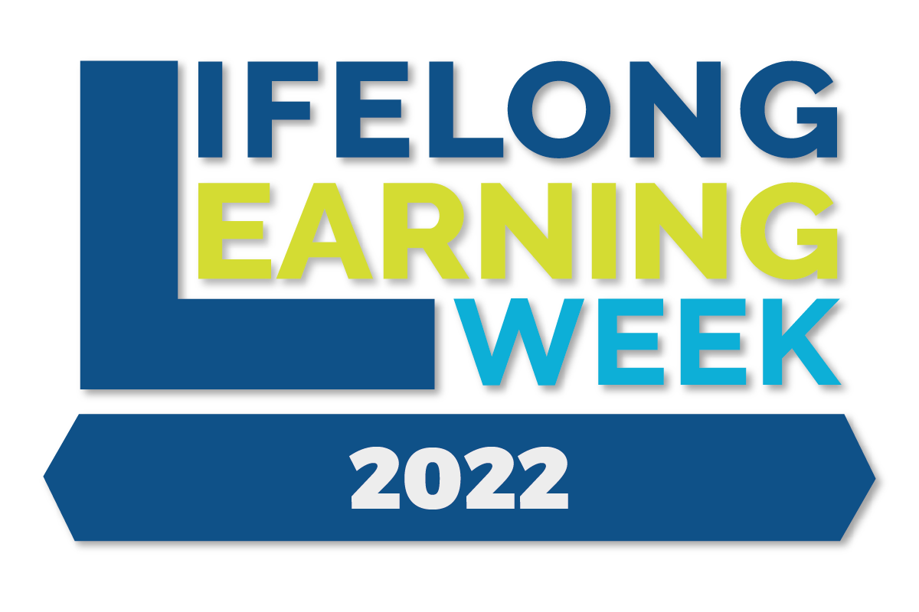
Organiser: ECSWE, Alliance for Childhood

When: 30 November, 12.00-13.30

Where: Brussels

87th Quality of Childhood (QoC) Talk:
Media Maturity and How to Build It?

Concept
The pressure for more and more digital tools in education can be connected with the benefits that this brings to the correlated markets. Analogue tools are often already easily accessible to kindergartens and schools as these were traditionally used in education and can often be put together or built with simple materials in the classroom. Education systems in Europe should not submit to the growing interest of the digital tools market but should always keep the best interest of its learners in the centre. Therefore the focus of this event will be on how educators and accompanying stakeholders can deliver lessons that aim at building the media maturity of the learners in the most effective way by the combination of analogue and digital tools.

The event will take the participants through the challenges inherent in existing digital media education policies. It will do this by bringing the results of the recently published German-wide research in the field. The MünDig Study which touches on whether a combination of analogue media (e.g. notebooks, flip-books and library visits) and digital media (e.g. tablets and PC) is the necessary combination for children and young people in order to learn to use media confidently. The study touches upon the question of which medium - analog or digital - is useful for what purpose and at what age. All this is to empower learners to build media maturity and avoid media addictions and its negative impacts on physical and mental health. To answer these challenges in schools by educators and at home by parents ECSWE has put together a project partnership HERMMES. In the next 3 years the partners will deliver curriculum, ideas on school policy guidelines and training that can empower all involved stakeholders in supporting learners in achieving media maturity.

Agenda

12.00 Words of welcome
Christopher Clouder, Alliance for Childhood
MEP Victor Negrescu, CULT Committee
12.15 The MünDig Study: findings and implications for education
Paula Bleckmann, Alanus University
12.45 HERMMES project: aims and relevance
Márti Domokos, ECSWE
12.55 Interactive activity
13.10 Reflections
Arja Krauchenberg, Lifelong Learning Platform & European Parents’ Association
DG EAC DELTA Working group representative (tbc)
13.20 Conclusions and closing words
MEP Victor Negrescu, CULT Committee

Moderation: Christopher Clouder, Alliance for Childhood

